FS-HTML5-Training

1. Create registration page using html5 ?

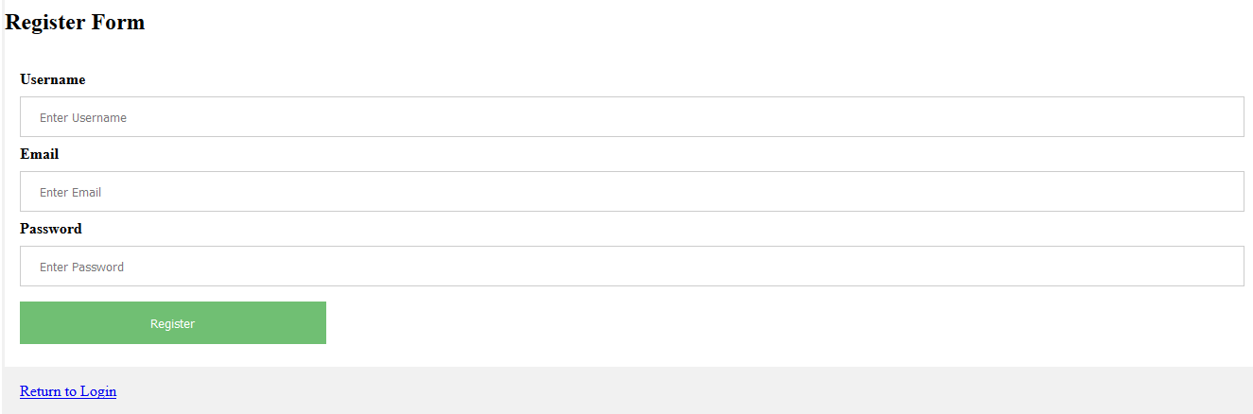

Figure Registration page

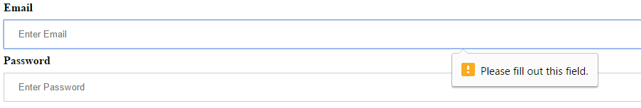

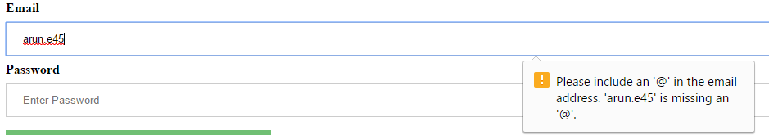

Figure Registration form validation

1. Create login page using html5 ?

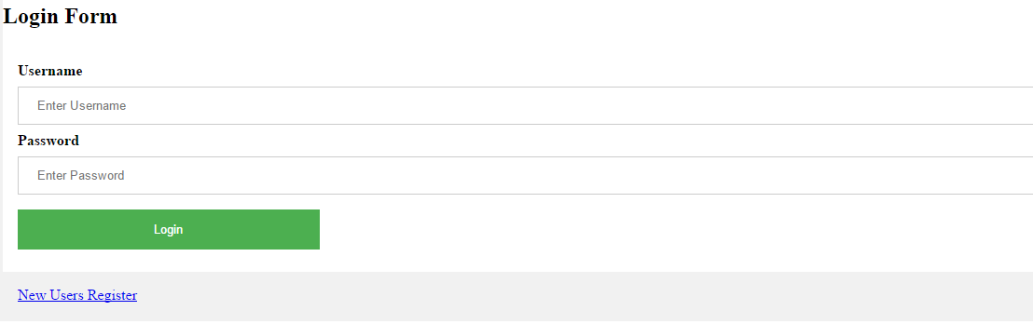

Figure Login page

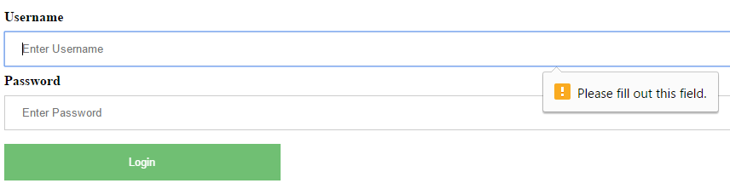

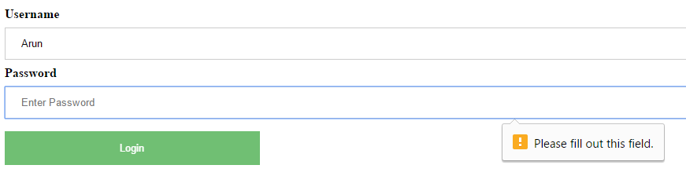

Figure Login form Validation

1. Draw a circle using html5 ?

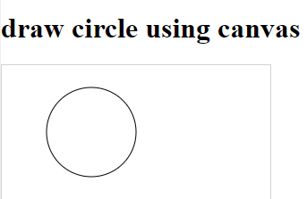

Figure Canvas circle

1. Create a program for session storage and local storage ?

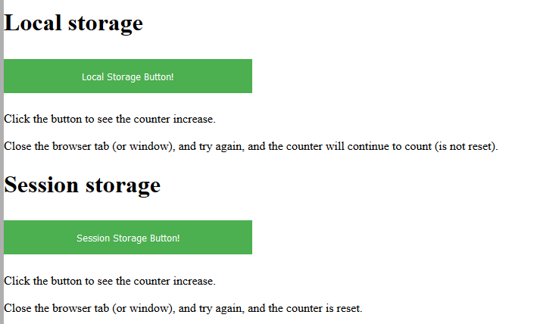

Figure Local and session storage -1

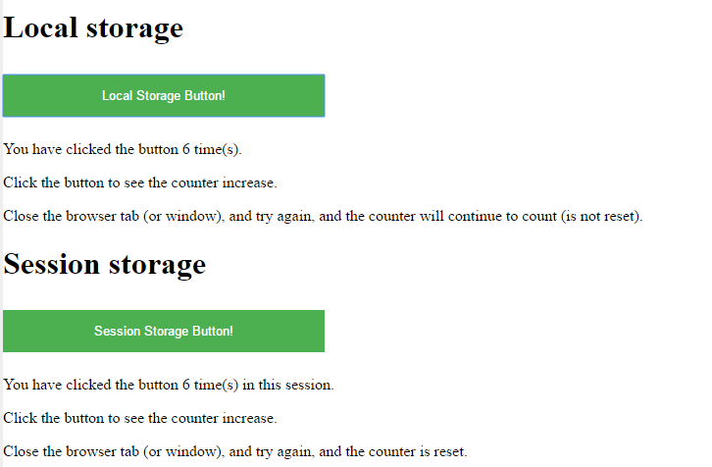

Figure Local and session storage -2

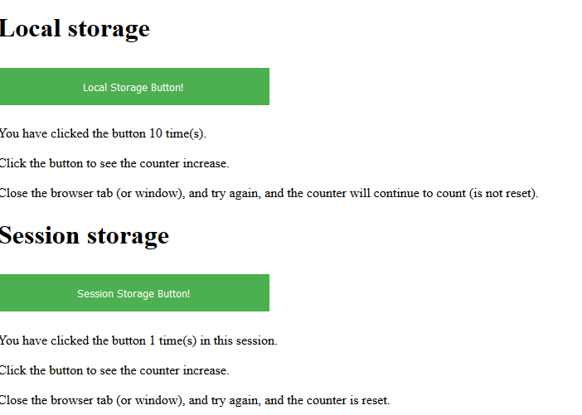

Figure Local and session storage -3

1. Create program for web socket ?



Figure Onclick on start - will contact demo-worker.js websocket till stop is clicked